8 May 2025

# Reminder of upcoming traffic changes | Carlisle Street | May 2025

Below the cliffs of Vaucluse and Diamond Bay, wastewater flows directly into the ocean untreated.

It’s time for change and we’re continuing to work to ensure this iconic area of Sydney gets the clean, blue backyard it deserves. Under the Refresh Vaucluse Diamond Bay project, we are building new infrastructure to divert the flows from the last three remaining ocean outfalls in Sydney to the Bondi Water Resource Recovery Facility (WRRF).

Further to our notification on 17 March 2025, stage 2 construction work and traffic changes on Carlisle Street will commence on **19 May 2025.** **Carlisle Street will remain open to traffic during this work**. Detours will be in place and traffic flow will be **one way** from the top end of Carlisle Street, before the intersection at Conway Avenue (please see detour map overleaf). **Temporary traffic impacts** will be in place **Monday – Friday between 7am – 6pm.** Maps are provided below and overleaf which show the work area, traffic changes and suggested detours.

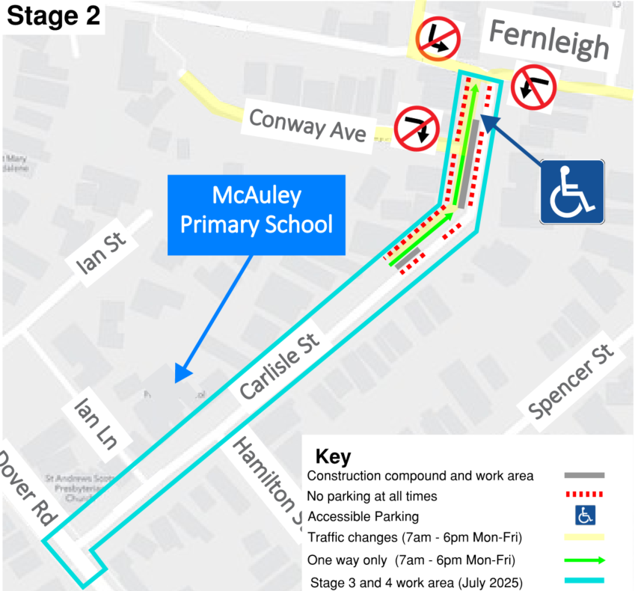**Carlisle Street work - stage 2**   
**Traffic changes and construction work Carlisle Street, Rose Bay**

**Stage 2 temporary traffic impacts Monday – Friday**

**7am – 6pm**

* One way traffic only, eastbound from 33 Carlisle Street to Fernleigh Avenue
* No right turn from Conway Avenue to Carlisle Street
* No left turn northbound from Fernleigh Avenue to Carlisle Street
* No left turn westbound from Chamberlain Avenue to Carlisle Street
* Access to driveways and properties will be maintained at all times under traffic control

We understand this work may impact the local community and thank you for your patience and understanding while we complete this important work.   
  
Traffic controllers and signage will be in place to help pedestrians and motorists around the work sites.

**Work activities from May 2025 include:**

* digging an exit pit for the underground drill in the road
* establishing a site compound for equipment
* installing underground pipes from Carlisle Street to Parsley Bay
* temporary removal of an additional (approximately 12) car spaces.

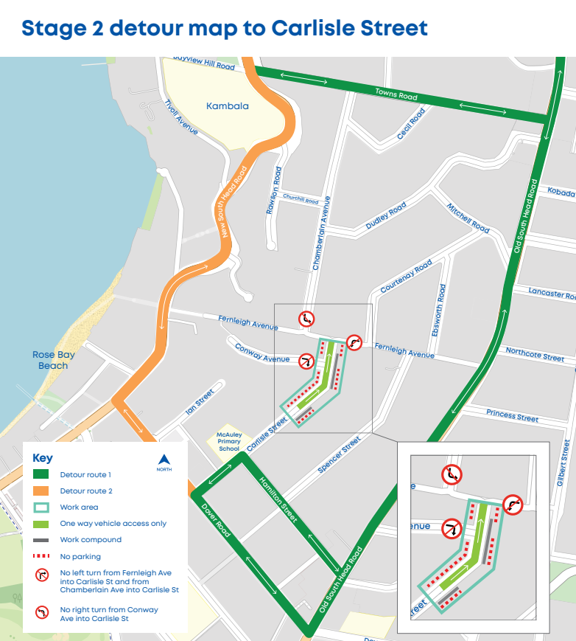

**Important information**

* Parking will be removed on both sides of Carlisle Street (from 33 Carlisle Street to Fernleigh Avenue intersection) to allow work to be completed safely. Spaces will be reinstated when work is completed
* Two-way traffic on Carlisle Street will be reinstated each weekday after 6pm and on the weekends
* Traffic control, signage, detours and digital message boards will be in place on Carlisle Street and the area to direct road users and for the safety of our crew, residents and road users
* The footpaths along Carlisle Street will remain open for pedestrians at all times
* Driveways will remain open for local resident access on Carlisle Street.

**Our work hours are Monday to Friday, from 7 am to 6 pm.** Traffic can flow through Carlisle Street outside of these hours.

We will provide regular updates to the community as the work progresses. If you have any questions, please contact our community engagement team on **1800 641 349** or email us on [**vauclusediamondbay@sydneywater.com.au**](mailto:vauclusediamondbay@sydneywater.com.au)