17 June 2025

# Geotechnical investigation | Ian Street Rose Bay| June 2025

Below the cliffs of Vaucluse and Diamond Bay, wastewater flows directly into the ocean untreated. It’s time for change and we’re continuing to work to ensure this iconic area of Sydney gets the clean, blue backyard it deserves. Under the Refresh Vaucluse Diamond Bay project, we are building new infrastructure to divert the flows from the last three remaining ocean outfalls in Sydney to the Bondi Water Resource Recovery Facility (WRRF).

In preparation for the construction of a new wastewater pipeline in Rose Bay, we will be carrying out additional geotechnical investigations on Ian Street, Rose Bay. This work is scheduled to start on **24 June 2025** and is expected to take **one day to complete**, weather permitting.

What’s happening

**Geotechnical investigations**

The work will involve borehole drilling (creating deep holes) and excavation (removing soil/rock) in sections of the road and nature strip. Borehole drilling is used to collect soil and rock samples to assess ground conditions. All activities will be carried out under the full-time supervision of project engineers.

During this period, you will notice some construction vehicles moving material and equipment around the work areas. Once the work has been completed all affected areas will be reinstated.

**Temporary removal of parking**

While Ian Street will remain open to traffic during these works, approximately seven car spaces located outside 2-4, 7-9, and 11 Ian Street will be temporarily removed, with "no parking" enforced in these areas.

The "no parking" zones will be clearly marked with traffic barriers and signs, indicating the dates when restrictions apply. We'll reopen these parking spaces once the work is done. For everyone's safety, traffic control and signage will be in place to protect our crew, residents, and road users.

A map is provided overleaf showing the work area.

Equipment

Equipment and machinery to be used for the work include:

* vacuum truck
* ground penetrating radars
* excavator
* drill rig.

To minimise impacts we will

• use dust suppression techniques

* stage our work in sections

• install noise blankets around work areas where possible, to minimise noise

• turn off machinery when not in use.

Our work hours

**Our work hours are Monday to Friday, from 7 am to 6 pm** and **Saturdays from 8 am to 1 pm.** There will be no work on **public holidays**. If we need to work outside these hours, we will notify residents in advance.

**Where the work is taking place**

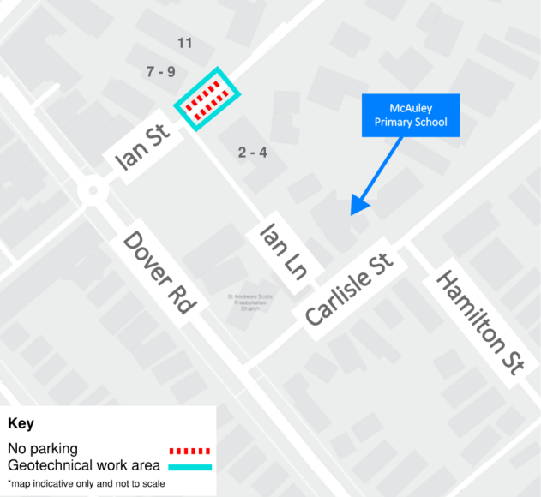

## Contact

We will provide regular updates to the community as the work progresses. If you have any questions, please contact our community engagement team on **1800 641 349** or email us on [**vauclusediamondbay@sydneywater.com.au**](mailto:vauclusediamondbay@sydneywater.com.au).

**Scan the QR code for the**

**project website or subscribe**

**for email updates.**