30 May 2025

# Geotechnical investigation work | Carlisle Street | June 2025

Below the cliffs of Vaucluse and Diamond Bay, wastewater flows directly into the ocean untreated. It’s time for change and we’re continuing to work to ensure this iconic area of Sydney gets the clean, blue backyard it deserves. Under the Refresh Vaucluse Diamond Bay project, we are building new infrastructure to divert the flows from the last three remaining ocean outfalls in Sydney to the Bondi Water Resource Recovery Facility (WRRF).

In preparation for construction of a new wastewater pipeline in Rose Bay, we will be conducting additional geotechnical investigations on Carlisle Street. This work is scheduled to start on **6 June 2025** and is expected to take **1 day to complete**, weather permitting.

## What’s happening

**Geotechnical investigations**

The work will involve borehole drilling (creating deep holes) and excavation (removing soil/rock) in sections of the road and nature strip. Borehole drilling is used to collect soil and rock samples to assess the ground conditions. All activities will be carried out under the full-time supervision of Project Engineers.

During this period, you will notice some construction vehicles moving material and equipment around the work area. Once the work has been completed all affected areas will be reinstated.

**Temporary removal of parking**

Carlisle Street will remain open to traffic during this work. Two car spaces will be temporarily removed outside of 14 Carlisle Street and ‘no parking’ will be in place for this work.

The areas of ‘no parking’ will be clearly delineated with traffic barriers and signs advising the date when no parking will apply. We will release this parking once the work is complete. To ensure the safety of our crew, residents and road users, traffic control and signage will be in place.

A map is provided overleaf showing the work area.

Equipment

Equipment and machinery to be used for the work include:

* vacuum truck
* ground penetrating radars
* excavator
* drill rig.

To minimise impacts we will

• use dust suppression techniques

* stage our work in sections

• install noise blankets around work areas where possible, to minimise noise

• turn off machinery when not in use.

Our work hours

**Monday to Friday, from 7 am to 6 pm** and on **Saturdays from 8 am to 1 pm.** There will be no work on **public holidays**. If we need to work outside these hours, we will notify residents in advance.

**Where the work is taking place**

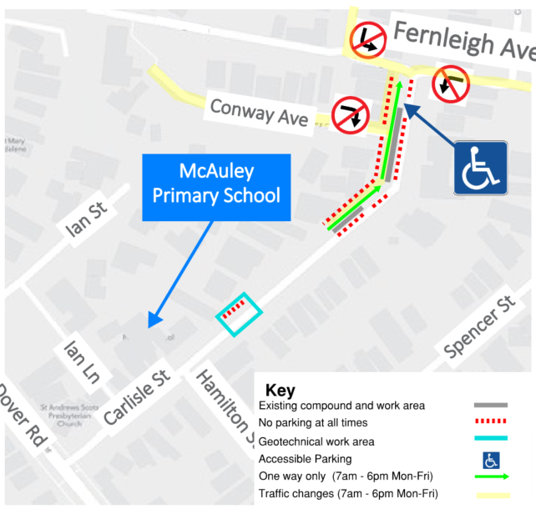

## Contact

We will provide regular updates to the community as the work progresses. If you have any questions, please contact our community engagement team on **1800 641 349** or email us on [**vauclusediamondbay@sydneywater.com.au**](mailto:vauclusediamondbay@sydneywater.com.au).

**Scan the QR code for the**

**project website or subscribe**

**for email updates.**